**Transforming Quadratic Graphs**

**1st: In your graphing calculator, graph the function y = x2 (the quadratic parent function).**

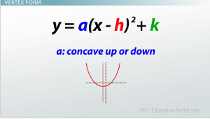**2nd: Compare the new graph (y2) to the parent.**

1. 

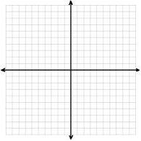

Vertex: ______________________________________________

Shape Change or Shift Change? : _________________________

What was the change? _________________________________

Domain: ____________________

Range: _____________________

End Behavior: ___________________________________

1. 



Vertex: ______________________________________________

Shape Change or Shift Change? : _________________________

What was the change? _________________________________

Domain: ____________________

Range: _____________________

End Behavior: ___________________________________

1. 



Vertex: ______________________________________________

Shape Change or Shift Change? : _________________________

What was the change? _________________________________

Domain: ____________________

Range: _____________________

End Behavior: ___________________________________

1. 



Vertex: ______________________________________________

Shape Change or Shift Change? : _________________________

What was the change? _________________________________

Domain: ____________________

Range: _____________________

End Behavior: ___________________________________

1. 



Vertex: ______________________________________________

Shape Change or Shift Change? : _________________________

What was the change? _________________________________

Domain: ____________________

Range: _____________________

End Behavior: ___________________________________

6. 



Vertex: ______________________________________________

Shape Change or Shift Change? : _________________________

What was the change? _________________________________

Domain: ____________________

Range: _____________________

End Behavior: ___________________________________

1. 



Vertex: ______________________________________________

Shape Change or Shift Change? : _________________________

What was the change? _________________________________

Domain: ____________________

Range: _____________________

End Behavior: ___________________________________

1. 



Vertex: ______________________________________________

Shape Change or Shift Change? : _________________________

What was the change? _________________________________

Domain: ____________________

Range: _____________________

End Behavior: ___________________________________

1. 



Vertex: ______________________________________________

Shape Change or Shift Change? : _________________________

What was the change? _________________________________

Domain: ____________________

Range: _____________________

End Behavior: ___________________________________

Summary and Practice



Even or Odd Function:

Even:

Odd:

Without your calculator, describe the transformations given the equation.

|  |  |
| --- | --- |
| y=(x + 5)2 - 7 |  |
| y=2(x - 4)2 |  |
| y= -x2 + 5 |  |
| y=.25(x - 7)2 + 1 |  |
| y= -6(x - 2)2 - 7 |  |

Given how the parent graph is shifted, write the transformed equation.

|  |  |
| --- | --- |
| Right 3, up 6 |  |
| Up 1, left 5, wider Down 2 |  |
| Right 4, narrower, and reflected over x-axis |  |