# Honors Math Plus NAME ___________________________________ Review DATE ____________________ PERIOD _______

**Read each choice carefully and find the best answer. Good Luck ☺**

1. Write the equation of a line with a slope of 3 and that passes through the point (-1,6)

a) $y=3x+9$ b) $y=3x-1$ c) $y=3x+6$ d) $y=-3x+9$

1. Write the equation of the line that passes through  and is perpendicular to .

a)  b)  c)  d) 

1. Cereal comes in several different size boxes. The chart below shows cost. Calculate a line of best fit and use it to predict the cost of a 15 oz box.

|  |  |
| --- | --- |
| Ounces | Price |
| 6 | $2.20 |
| 8 | $2.80 |
| 16 | $5.22 |
| 32 | $9.98 |

a) $4.90 b) $4.28 c) $5.00 d) $5.20

1. Which of the given lines are parallel? I.  II.  III. 

a) II and III b) I and III c) I and II d) none are parallel

1. What is the equation of the horizontal line passing through the point ?

a)  b)  c)  d) 

1. What is the equation of the vertical line passing through the point $(-4,-3)$?

a) $y=-4$ b) $x=-4$ c) $y=-3$ d) 

1. Which is the equation of the line passing through and ?

a)  b)  c)  d) 

1. Which is the solution of ?

a)  b)  c) no solution d) 

1. Solve: ?

a)  b)  *or*  c)  *or*  d) 

1. The graph of  is translated down 3 units and right 2 units. What is the equation of the new graph?

a)  b)  c)  d) 

1. Solve  for *t*.

a)  b)  c)  d) 

1. Which graph shows the solution for the linear inequality  ?

a) 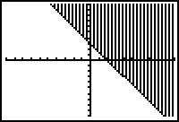 b) 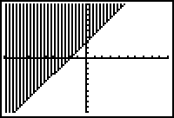 c) 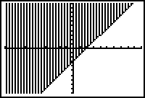 d) 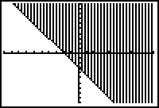

1. Graph y = | x – 3| + 2.

a) 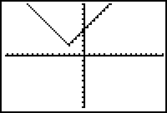 b) 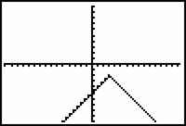 c)  d) 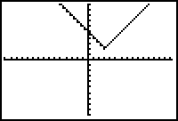

1. Solve 

a)  b)  c)  d) 

1. Solve the system .

a)  b)  c)  d) 

1. Solve by substitution. 

a) (2, 1) b) (2, -1) c) (1, -2) d) (-2, -1)

1. Classify as independent, inconsistent, or dependent. 

a) inconsistent b) dependent c) independent d) all of the above

1. Mike sells afternoon matinee movie tickets for $5.25 each and evening shows for $7 each at a local movie theater. The theater made $2016 altogether and sold a total of 318 tickets. How many evening tickets were sold?

a) 318 b) 198 c) 2016 d)120

1. You want to solve the system of linear equations by eliminating *x*. If you multiply the top of the equation by 3, by which number would you multiply the bottom equation?

a)  b) 2 c) -3 d) 3

1. What is the solution of the inequality ?

a)  b) no solution c)  d) all real numbers

1. Which graph represents the system of inequalities ?

a)  b)  c) ****d) 