**Honors Math 2 HW 1-1 Name _________________________**

Factor completely:

1. 4d4 – 2d10 + 12d5 2. 8x6 + 2v5 – 10x9 3. 24a2b5 – 48a3b7

4. 2x2 + 4xy – 6x – 12y 5. 2ah + h + 2ab + b 6. X2 – 25

7. 2a2 + 4a + 3ab + 6b 8. 25d3 – 100d2 – d + 4 9. y3-7y2 + 4y – 28

10. 9g2 – 25 11. X4 – 16 12. 3x2 - 75

**Honors Math 2: Factoring HW 1-2**

|  |  |  |
| --- | --- | --- |
| 1. x2 – 18x + 80 | 2. 5x2y - x2 + 5y - 1 | 3. 3y2 – 15y + 18 |
| 4. a3 – a2b + ab2 – b3 | 5. x4 – 15x3 + 56x2 | 6. k2 – 8k + 16 |
| 7. 2z2 – 12z + 18 | 8. c4 + c3 – 12c - 12 | 9. 25y2 – 100 |

**HW 1-3: Solving Quadratic Equations**

**Solve each equation by factoring.**



j0428065[1]

**HW 1-4**

I. For each graph fill in the blanks for the requested information.

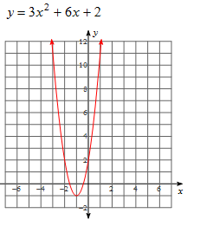a) Vertex:______

Zeroes:_____________

y-intercept:_________

Axis of symmetry:_________

Decreasing interval:_________

Increasing interval:__________

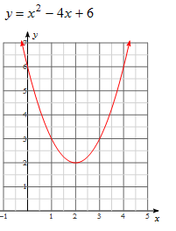b) Vertex:______

Zeroes:_____________

y-intercept:_________

Axis of symmetry:_________

Decreasing interval:_________

Increasing interval:__________

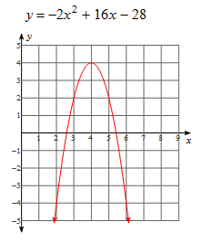

c) Vertex:______

Zeroes:_____________

y-intercept:_________

Axis of symmetry:_________

Decreasing interval:_________

Increasing interval:__________

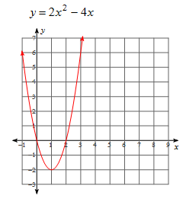d) Vertex:______

Zeroes:_____________

y-intercept:_________

Axis of symmetry:_________

Decreasing interval:_________

Increasing interval:__________

II.

Equation . Axis of Symmetry Vertex Factor x-intercept y-intercept

y = x2 +8x +15

*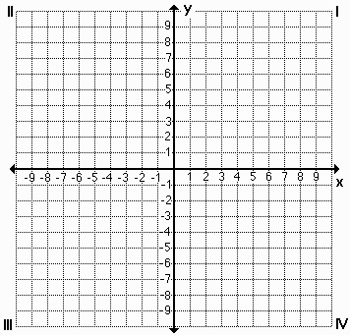 Graph the function above Graph the function below*

Equation Axis of Symmetry Vertex Factor x-intercept y-intercept

y = x2 +2x-24

**HW 1-5**

1. A ball is thrown straight up with an initial velocity of 56 feet per second. The height of the ball ***t*** seconds after it is thrown is given by the formula

MCj04324650000[1]**h(t) = 56t – 16t2.**

1. What is the height of the ball after 1 second?_______________________
2. What is its maximum height?____________________________________
3. After how many seconds will it return to the ground? _________________
4. A baseball is projected upward from the top of a 448 foot tall building with an initial velocity of 48 feet per second. The distance **s** of the baseball from the ground at any time **t**, in seconds, is given by the equation s = -16t2 + 48t + 448.

a. Find the time it takes for the baseball to strike the ground. ________

b. What is the baseball’s maximum height?___________

Use the formula where **h(t)** is the height of an object in feet,  is the object's initial velocity in feet per second, and **t** is the time in seconds for #3.

3. An arrow is shot upward with a velocity of 64 feet per second. Ignoring the height of the archer, how long after the arrow is released does it hit the ground?_____________

4. At 1821 feet tall, the CN Tower in Toronto, Ontario, is the world’s tallest self-supporting structure. Suppose you are standing in the observation deck on top of the tower and you drop a penny from there and watch it fall to the ground. The [table](javascript:def('/Glossary/glossaryterm.aspx?word=Table',%20500,%20500);) below shows the penny’s distance from the ground after various periods of time (in seconds) have passed. Where is the penny located after falling for a total of 10.5 seconds?

|  |  |  |  |  |  |  |
| --- | --- | --- | --- | --- | --- | --- |
| Time(seconds) | 0 | 2 | 4 | 6 | 8 | 10 |
| Distance(feet) | 1821 | 1757 | 1565 | 1245 | 797 | 221 |



a. Find the quadratic model.

b. Where is the penny located after falling for a total of 10.5 seconds?_____

**HW 1- 6**

I. Greg, Keith and Dan were at the skate park. They decided to use a three foot ramp to see who could jump the highest. The paths of their jumps are given below.

|  |  |
| --- | --- |
| x | y |
| 0 | 3 |
| 4 | 5 |
| 6 | 3 |

Greg: y = -x2 + 4x + 3 Keith: Dan:

1. Who had the highest jump?
2. Who had the lowest jump?
3. Who had the longest jump?
4. What was the difference in height between the highest and the lowest jumps?

II. For each graph fill in the blanks for the requested information.

a) $y=x^{2}+8x+15$ b) $y=-2x^{2}-16x-29$

Vertex:______ Vertex:______

Zeroes:_____________ Zeroes:_____________

y-intercept:_________ y-intercept:_________

Axis of symmetry:_________ Axis of symmetry:_________

Decreasing interval:_________ Decreasing interval:_________

Increasing interval:__________ Increasing interval:__________



**HW 1-7**

Suppose some very “Angry Birds” are attacking some “pigs” in a castle by using a slingshot to launch themselves at castle walls. Depending on the angle that they are launched at, they will either shoot long and far or high and short. The data about how each slingshot launches each bird is listed below:



1. How “far” will each slingshot launch each bird? If the castle is far away, which slingshot should they use and why? If the castle is near, which slingshot should they use and why?
2. Analyze the slingshot data and compare to determine which slingshot shoots the birds the highest. Explain how you know.
3. If the castle walls are 30 feet tall, which slingshot should you use and why?
4. What are the pros and cons of using each Slingshot A, B, or C?