**Honors Math II Notes Unit 1 ~ Day 1**

**Factoring Review**

* Factors
  + Recall: When 2 or more numbers are multiplied to form a product, each number is a “factor” of the product.
    - Factors of 12: ______________________
* Factoring Polynomials
  + ALWAYS factor out the _______________ _____________ _____________ (_______) FIRST!!!
  + A polynomial that can not be factored is ____________.
  + A polynomial is considered to be completely factored when it is expressed as the product of prime polynomials.

# _________________________________________________________

1. Factoring out the GCF:
   1.  b. 
   2.  d. 24a3b4c – 72ab4
2. Factor by grouping—for polynomials with 4 or more terms
   1.  b. 
   2.  d. 6x3 + 9x2y – 15y2 – 10xy
3. Difference of “Two Squares”

Rule: _______________________________________

1.  b. 
2.  d. 3x2 - 75

Factoring Review Unit 1 Day 2

A. Factoring trinomials into the product of two binomials

a. When leading coefficient is not one

1)  2) 

3)  4) 

b. When leading coefficient is one.

5)  6) 

7)  8) 

8) 

_______________________________________________________________________

The area in square meters of a rectangular parking lot is x2 – 95x + 2100. The width is x – 60. What is the length of the parking lot in meters?

**Concept Summary: Polynomial Factoring Techniques**

|  |  |
| --- | --- |
| **Techniques** | **Examples** |
| **1. Factoring out the GCF**  Factor out the greatest common factor of all the terms |  |
| **2. Factoring by Grouping** |  |
| **3. Quadratic Trinomials**  “Bustin up the B” |  |
| **4. Difference of Two Squares** |  |

**Unit 1 ~ Day 3**

**Solving Quadratic Equations by Factoring**

**Zero Product Property:**

* Let A and B be real numbers or algebraic expressions. If AB=0, then A=0 or B=0.
* This means that If the product of 2 factors is zero, then at least one of the 2 factors had to be zero itself!

**Solving or Finding the Zeros of an Equation**

* The zeros of an equation are the ____________!
* First, change y to a _________. Now, solve for ____.
* The solutions will be the ________ of the equation.

Ex: Solve.

A)x2 + 3x - 18 = 0 B)2t2 - 17t + 45 = 3t – 5

C)3x - 6 = x2 – 10 D) y = x2-x-6

**You TRY!!!**

1. 2x2 + 15 = 13x 2. 16x2 = 8x

**Graphing Quadratic Equations Unit 1 Day 4**

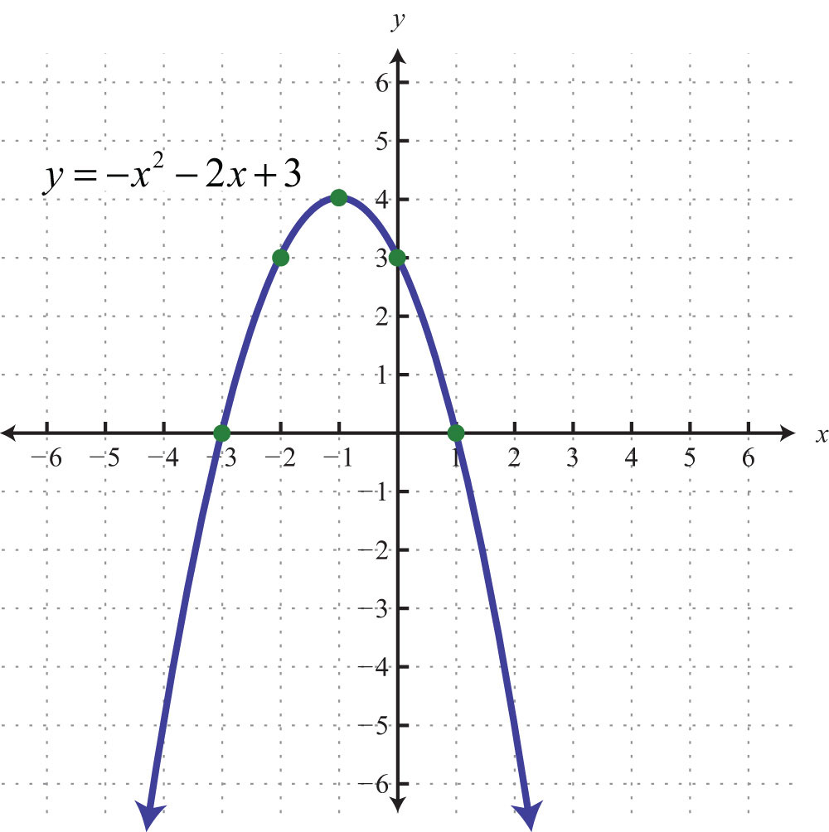

**The anatomy of a parabola...**

**Examples 1: Graph y = x2 -6x + 8 by hand...**

**Finding the zeros: Find the y-intercept:**

**Find the AOS: Find the vertex:**

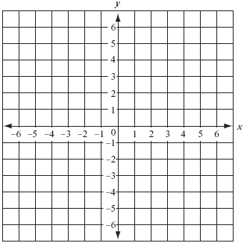

**Max or Min?:**

**Increasing Interval:**

**Decreasing Interval:**

**Example 2: y = x2 - 4x + 3**

1) Solution:______

2) x-intercepts: ________

3) y-intercept:_________

4) Axis of symmetry:_________

5) Vertex:_____________

6) Max/Min: _________

Decreasing interval:_________ Increasing interval:__________

**Example 3: y = -2x2 + 2x + 12**

1) Solution:______

2) x-intercepts: ________

3) y-intercept:_________

4) Axis of symmetry:_________

5) Vertex:_____________

6) Max/Min: _________

Decreasing interval:_________ Increasing interval:__________

**Example 4 on Calculator: y = 15x2 + x**

****1) Solution:______

2) x-Intercepts: ________

3) y-intercept:_________

4) Axis of symmetry:_________

5) Vertex:_____________

6) Max/Min: _________

Decreasing interval:_________ Increasing interval:__________

**Example 5 on Calculator: y = 4x2 - 9**

1) Solution:______

2) x-Intercepts: ________

3) y-intercept:_________

4) Axis of symmetry:_________

5) Vertex:_____________

6) Max/Min: _________

Decreasing interval:_________ Increasing interval:__________

**Applications of Quadratic Equations Unit 1 Day 5-6**

1. A bottlenose dolphin jumps out of the water. The path the dolphin travels can be modeled by

*h* = , where h represents the height of the dolphin and d represents the horizontal distance.

1. What is the maximum height the dolphin reached?
2. How far did the dolphin jump?
3. Jaime owns a business making decorative boxes to store jewelry, mementos, and other valuables. The function P(x) = -models the profit P(x) that Jaime has made in month x for the first two years of her business.
4. What was the initial start up cost of her business?
5. During what month did Jamie make the most money?
6. What was the most Jamie made?
7. A Field Hockey player makes a scoop that releases the ball with an upward velocity of 34 ft/s. The function

*h = -16t2 + 34t* models the height h in feet of the ball at time t in seconds.

1. Does the ball ever reach 20 feet?
2. How high does the ball travel?
3. How high is the ball at 2 seconds? At 3 seconds?
4. When will the ball reach the ground?

3. A toy rocket is shot upward from ground level. The table shows the height of the rocket at different times.

|  |  |  |  |  |  |
| --- | --- | --- | --- | --- | --- |
| **Time (seconds)** | 0 | 1 | 2 | 3 | 4 |
| **Height (feet)** | 0 | 256 | 480 | 672 | 832 |

a. Find a quadratic model for this data.

b. Use the model to estimate the height of the rocket after 1.5 seconds.

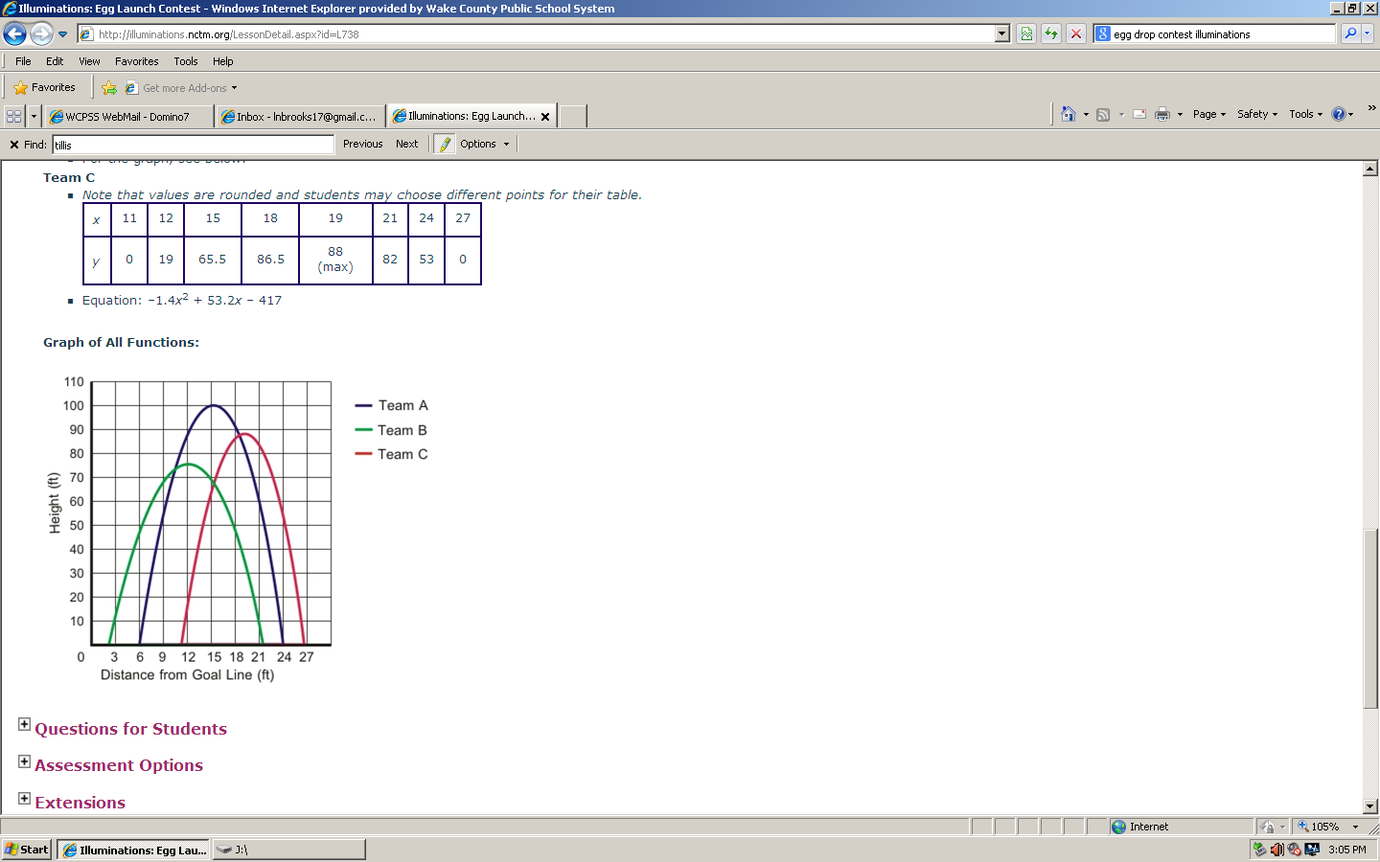

1. Which parabola had the highest point?
2. Which parabola had the furthest horizontal distance?
3. Write the equation for the parabola with the highest point.

Putting them all together….

1. The baseball team has decided to have a throwing contest. Below is the data for 3 different players.

**Joe Michael Henry**

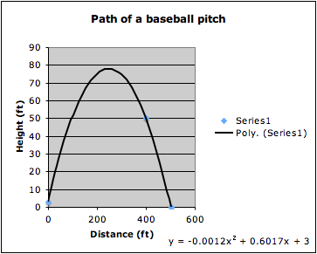

|  |  |
| --- | --- |
| **Time (x)** | **Height (y)** |
| **.5** | **37.5** |
| **1** | **63** |
| **2** | **90** |
| **3** | **85** |

**y = -16x2 + 50x + 5**

0 1 2 3

**Time (seconds)**

1. Whose ball was in the air the longest?
2. Who threw their ball the highest?
3. If you were to determine the winner of the contest, who would you choose and why?
4. Three surveyors are having a discussion about bridges in New York City. The first surveyor collected data from the Verrazano Bridge, he measured the height of the cable as he drove from one end to the other. The second surveyor took a picture of the cable for the Brooklyn Bridge. The last surveyor came up with an equation to model the cable height of the Tappan Zee bridge.

**Verrazano Bridge**

**Brooklyn Bridge**



|  |  |
| --- | --- |
| Horizontal Distance (x) | Height of Cable (y) |
| 0 | 160 |
| 100 | 114.4 |
| 200 | 77.6 |
| 300 | 49.6 |
| 400 | 30.4 |
| 500 | 20 |

**Tappan Zee Bridge**

**y = .00025x2 - .2x + 100**

1. Using the information, determine the length of each bridge to decide which one is longest and shortest.
2. Which bridge’s cable gets the closest to the road? How do you know this?
3. Analyze the data to determine which bridge a trucker should use if their truck’s height is 15 ft. How did you come to this conclusion? Which bridge should he avoid and why?