Unit 7 Part 2 Factoring Review!! ☺

Factor each of the following:

|  |  |
| --- | --- |
| $6x-36$ | $m^{2}-49$ |
| $16x^{3}+8x^{2}+30x+15$ | $y^{2}+6y+9$ |
| $36a^{2}b^{4}+27ab$ | $2h^{2}-13h-15$ |
| $4x^{2}-16$ | $64n^{2}-16n+1$ |
| $2g^{2}-g-28$ | $k^{2}+5k-66$ |

Review ☺

1. 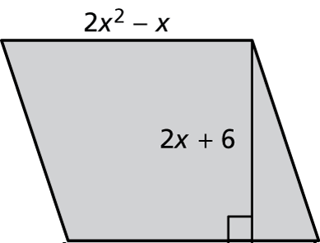Find the polynomial which represents the area for the parallelogram below.

**Area of Parallelogram = (base)(height)**

$$3x^{2}-x$$

$$4x+3$$

1. Solve and graph the inequality $x-4<0$.

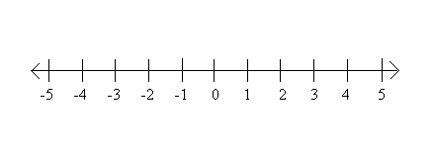

1. 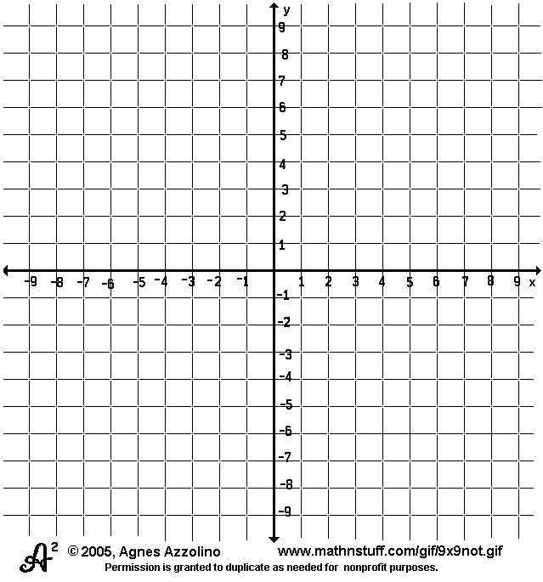 Graph the system of linear equations:
$$y=\frac{5}{2}x-4$$

$$y=x+2$$

2. In 32 years, David’s age will be twice what it is today. If d represents David’s age, determine an equation that can be used to find d.
3. Using the table below, find the linear function that relates y to x.

|  |  |  |  |  |  |
| --- | --- | --- | --- | --- | --- |
| X | 1 | 3 | 5 | 7 | 9 |
| y | 13 | 15 | 17 | 19 | 21 |

1. Using the table below, find the linear function that relates y to x.

|  |  |  |  |  |  |
| --- | --- | --- | --- | --- | --- |
| X | 1 | 3 | 5 | 7 | 9 |
| y | 25 | 22 | 19 | 16 | 13 |

In order to CHECK all polynomials that have been factored we can _____________! To be sure we haven’t forgotten let’s find some products ☺